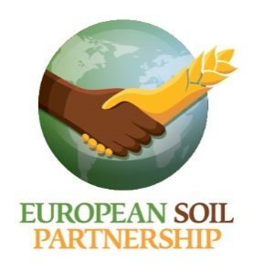

**9th EUROPEAN SOIL PARTNERSHIP PLENARY MEETING**

**5 May 2022 10:00 – 13:00 and 14:00 – 17:00 (Zoom meeting)**

*Chair: Rainer Baritz (European Environment Agency)*

*Secretariat: Nicole Wellbrock (Federal Research Institute for Rural Areas, Forestry and Fisheries)*

*Registration:* <https://thuenen.limequery.com/161987?lang=en>

**Draft AGENDA**

**Session I: 10:00 – 13:00**

**1. Opening** (Welcome, agenda, tour de table)

**2. Reports**

2.1 Overall status and challenges: Chair

2.2 Information from the Sub-Regional Soil Partnerships:

- Alpine, Pyrenean, Eurasia, steps towards a new Western Balkan partnership

2.3 GSP: global activities with participation from ESP members

2.4 ITPS: ongoing activities with needed input from ESP members

- Europe Chapter of the 2nd Status of the World’s Soil Resources Report

2.4 Initiatives related to Pillars/action areas:

- Pillar 1: Current activities towards defining sustainable soil management in Europe

- Pillar 2: New EU soil governance affected by the EU Soil Strategy 2030, including role of the European Soil Observatory to support ESP activities

- Pillar 3 (Research): unique soil research landscape in Europe: (a) European Joint Programming Soil; (b) Germany: Soil research programme for the Bioeconomy

- Pillar 4 and 5: level of participation, objectives, products, from ESP members, data exchange: (a) INSII, (b) EUROSOLAN

**Session II: 14:00 – 17:00**

**3. Invited talks**

3.1 Action area: soil governance and advocacy on soil health: Developments of EU soil-related policies, and its impact and challenges towards the whole ESP

3.2 Action area: Promote knowledge on soil: Soil research landscape in Europe driven by the EU Mission: A Soil Deal for Europe, including relevance for EU neighbours

3.3 Action area: Assess, map, and monitor soil health: A data base of peatland soils in Europe

**4. Preparations for the GSP Plenary Assembly**

4.1 Discussion of all decision-making points, and how this affects the ESP

4.2 Summary, and future objectives of the ESP

**5. ESP Secretariat** (nominations and vote)

5.1 Activities of the ESP secretariat

**6. Closing remarks**

6.1 Conclusions and observations from partners

6.2 Next ESP Plenary assembly: date, location

6.3 World Soil Day 2022

6.4 Closing